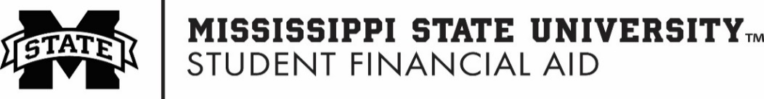
This Form with Required Supporting Documents can be submitted via:
Upload to: sfa.msstate.edu/dawg-documents
Mail to: P.O. Box 6035, Mississippi State, MS 39762-6035

Parent PLUS Information Form
2023-2024
_______________________________________ ______________________________
Student’s Name MSU ID (9-digit)
This is NOT a Direct PLUS Application
To apply for Direct Plus loan, please visit studentaid.gov
Direct PLUS loans are federal loans that parents of dependent undergraduate students can use to help pay for college expenses that are not covered by other financial aid.
To borrow a Direct PLUS Loan for a dependent undergraduate student, the parent must be the student’s biological or adoptive parent, or in some cases, a stepparent. A legal guardian is not considered a parent for federal student aid purposes.
Parent PLUS Loan borrowers and their dependent child must be U.S. citizens or eligible noncitizens, must not be in default on any federal education loans or owe an overpayment on a federal education grant.
Our records indicate that you have already applied for a Direct PLUS loan. However, the parent listed on the Direct PLUS application is not listed on your FAFSA application. Before we can proceed with your application, please verify the parental information below and submit form to our office.
Parent Borrower Information:
Parent Borrower Last Name: First Name: Middle Initial:
Parent Borrower Home Address:
Street: City & State: Zip:
Parent Borrower’s Relationship to Student  (check ONE): |  |  |  | - Biological parent |  | - Adoptive parent  (awarded by a judge) |  | - Stepparent  (Information on FAFSA)
Parent Borrower’s Social Security Number (Last 4 digits): (Must Attach Copy)
Parent Borrower’s Date of Birth: |  |  |  |  | Parent Borrower’s Phone Number:
Parent Borrower’s U.S. Citizenship Status (check ONE below that applies): Documentation required:
- U.S. Citizen or National  (attach Birth Certificate or Passport) |  |  | - Permanent Resident  (documentation required) |  |  |  | - Eligible Noncitizen  (documentation required)
Are you currently in default on a federal education loan, or do you owe a refund on a federal student grant?
- Yes | - No
Parent Certification Statement:
By signing this form, I certify that all the information reported on it is complete and correct. Warning: If you purposely give false or misleading information on this form, you may be fined, sentenced to jail, or both.
Parent Borrower’s Signature: |  |  |  |  |  |  |  |  | Date:

